**Resume Of**

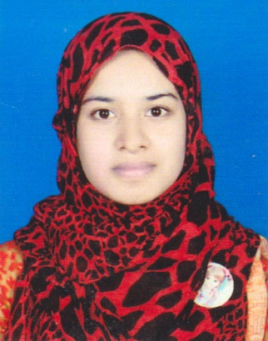

**Marina Naznin**

Recent Address: Dhanmondi, Dhaka, Bangladesh.

Permanent Address**:** Naikani Bari, Thana: Basail, Post: Mirikpur, Tangail .

**Contact No:  +8801795663310**

**Email:** [**marina15-9568@diu.edu.bd**](mailto:marina15-9568@diu.edu.bd)

**Career Objective:**

To build a career that encounters challenge and creativity as well as builds the life in the light of honesty, dynamism for developing both the psychological and organizational position and being a professional team worker to enrich the decision-making ability.

**Curriculum Vitae:**

**Started from most recent degree:**

**Name of Degree             : B.Sc. in CSE**

Institution               : **Daffodil International University**

Department               : CSE Engineering: (Computer Science & Engineering)

Result               : 12 Semester Running

Year               : 2021

**Name of Degree            : H.S.C (Higher Secondary Certificate)**

Institution               **: B.A.F Shaheen College, Paharkanchanpur**

Result               : C.G.P.A-5.00 Out of 5.00

Board               : Dhaka

Year               : 2016

**Name of Degree         : S.S.C (Secondary School Certificate)**

Institution : **Bharateswari Homes**

Group : Science

Result : G.P.A. – 5.00 Out of 5.00

Board : Dhaka

Year : 2014

**Personal Details:**

Name : Marina Naznin

Father’s   Name : A.M Mashiour Rahman

Mother’s   Name : Farida Rahman

Date of Birth : 13/04/1998

Permanent Address : Village- Naikani Bari; Thana- Basail,

Post- Mirikpur, Tangail,

Present Address : Dhnmondi, Dhaka Bangladesh

Marital Status : Married

Religion : Islam

Nationality : Bangladeshi (By Birth)

Gender : Female

Blood Group : B (+)

**Extra Qualification:**

* Microsoft Word
* Power point
* Networking, Browsing.

**Language Proficiency:**

Good command over speaking, reading, writing, listening and speaking both in English & Bengali

**Skills:**

# Teaching

# Communication

# Leadership

# Writing

# Microsoft word, power point

I declare hereby that all information I have presented so far are true to my knowledge. If required and where applicable, this document can be supported by authentic certificate/ papers.

**Signature:**

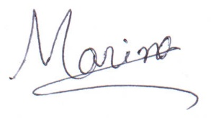

**( Marina Naznin)**

**Date :**